**Name**: Nermeen Sayed Abd elrazek Hassen Gad

**B.N/990**

**Date**: 9-6-2021

**Topic**: Big Data

**Application Brief**:

I chose this topic because I am interested in it and I am curious to know about it.

**GitHub-Link:**

**GitHub-Page(Published Website):**

**Screenshots:**

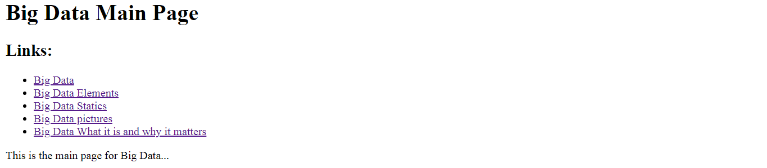

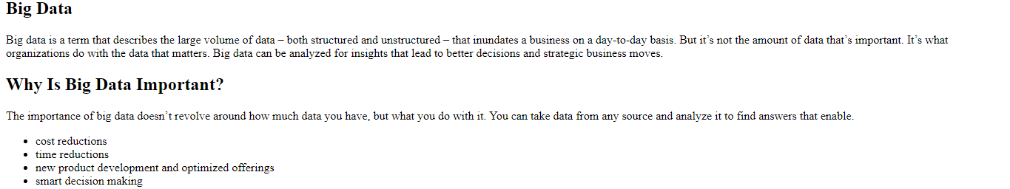

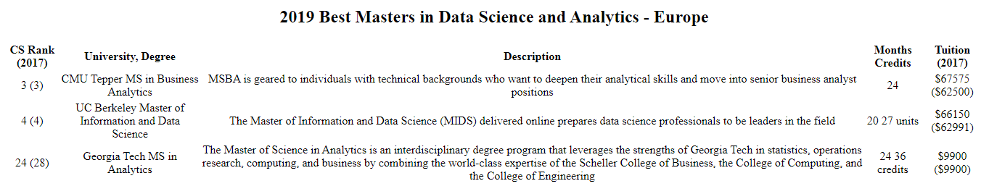

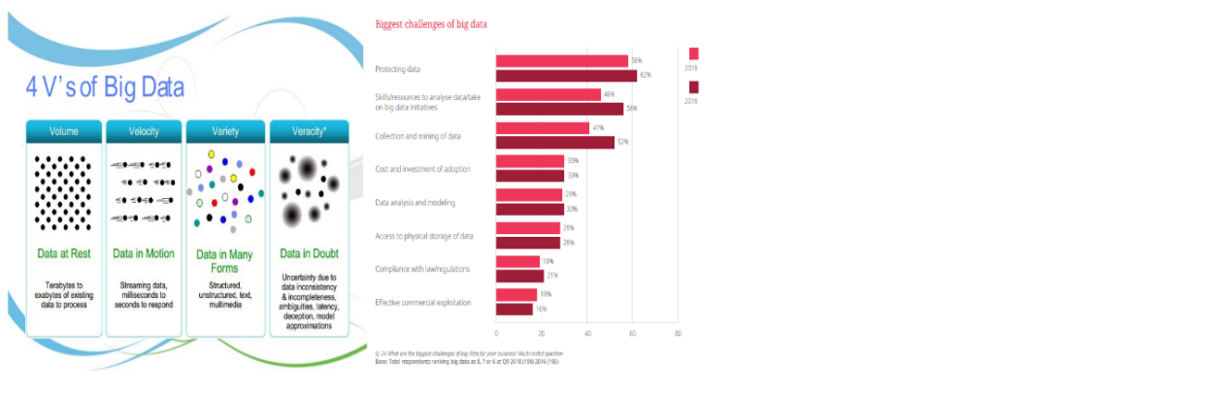

**Source Code**:

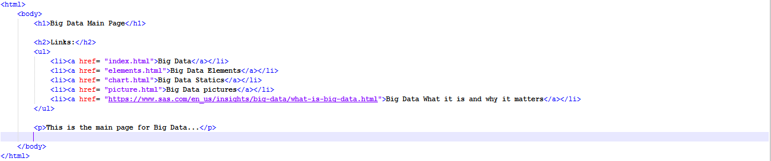

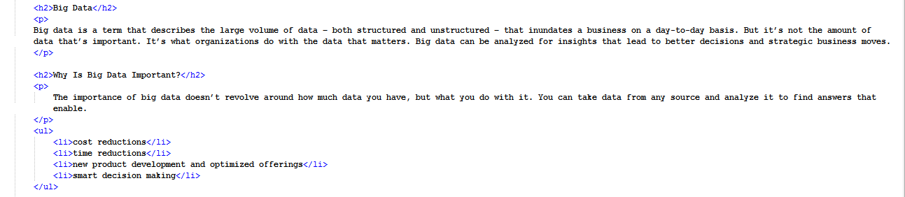

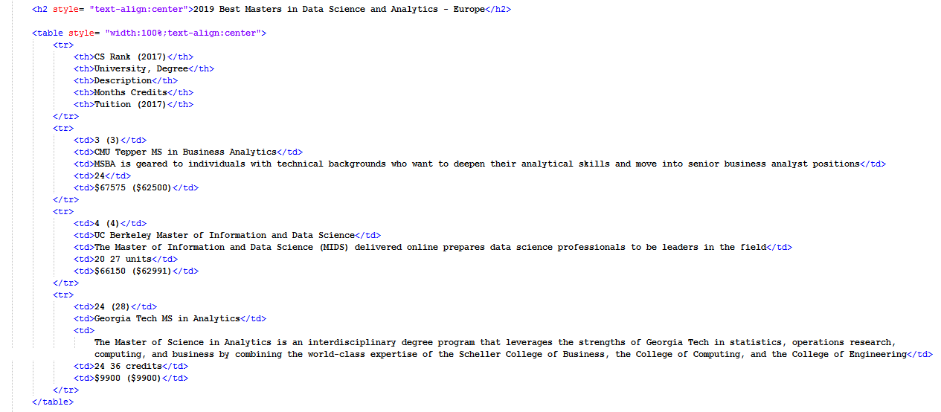

8